The PHP project [recently discovered](https://github.com/php/php-src/commit/2b0f239b211c7544ebc7a4cd2c977a5b7a11ed8a) that attackers were able to gain access to its main Git server, uploading two malicious commits, including a backdoor. They were discovered before they went into production.

Both commits addressed a “typo” in the source code. They were uploaded using the names of PHP’s maintainers, Rasmus Lerdorf and Nikita Popov.

The commits were caught by other, more active maintainers.

I spoke with [Michael Voříšek](https://github.com/mvorisek), - the PHP maintainer who discovered the backdoor attempt - Michael was kind enough to reply, and even suggest some great techniques for other detection models; whilst cautioning about overall high rates of false positives I’m likely to run into.

My intent in reaching out was I wanted to find out if there was anything that rung alarm bells or felt unusual. I had (meta)data associated with the event, and certainly some things looked unusual, but without Michael’s context I couldn’t be sure if it actually felt that way up close. - _Was this the long tail event that it looked like?_

Time in history:
https://github.com/php/php-src/commits/master?after=26860c6b6a5b6a246c03ba5220e9699868193e25+454&branch=master

I created a set of assumptions for my modeling of this event, and I wanted to see if that aligned with Michael’s experience. After all, if that wasn’t the case, how could it ever be considered actionable intelligence in the real world? I can’t have each modeling just morph to fit every prior event if I expect to make a novel detection in the future, the alert pushes to humans need to be high confidence to begin with, even if that means missing things.

Before I spoke to Michael, I established the following unnusual activity:
about both the commit, and committer @rlerdorf.

-rlerdorf last committed to PHP-src in Oct 23 (by accident), prior to that, May 21, 2019.
- No good data on usual commit times or behavior.
-Wrote ‘ fix typo’ but commit was large, larger than other commits in a 12 month period by a significant margin. The largest commits behind ‘fix typo’ was for branch merges listed as being part of a new version in 7/2020.

This was also unusual activity for a weekend (local time for commit author) although I don’t put too much weight in this.

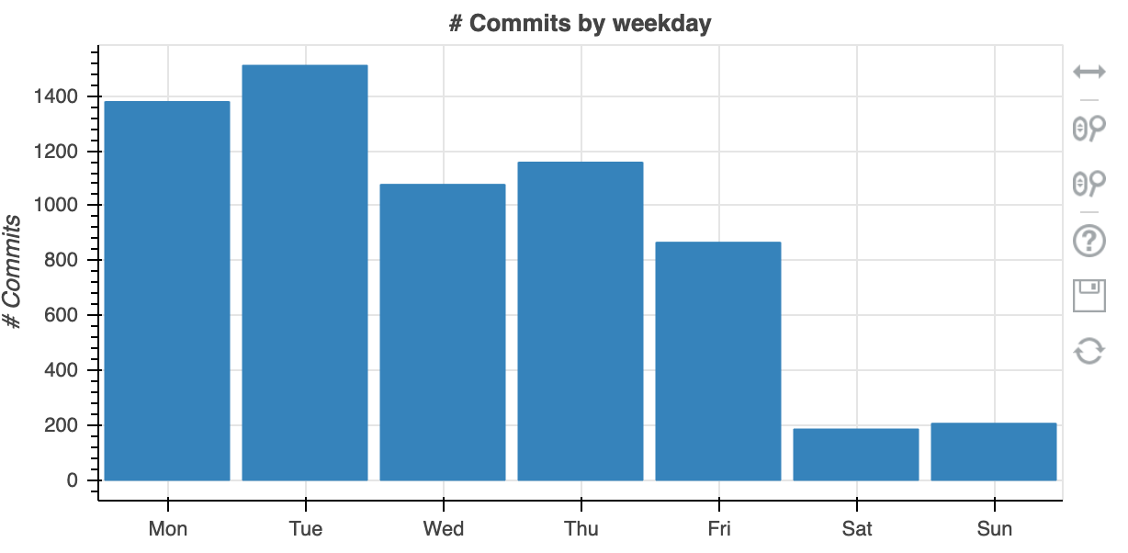

Obviously the commit itself was bad, but I am focused on macro-scale metadata analysis which is language agnostic.

-Unsigned commit (most contributors and maintainers don’t at the time of the event), but that is still risky behavior.
-Maybe half of commits since the event are now signed, a large increase in the right direction.

Michael wrote in response to my question:

>”In that particual php-src commit, "fix typo" definitely caught my attention as this wording is never used to fix more than cosmetical changes in such large project.”

So basically, after seeing the commit size and the description/summary, Michael was already at attention!

This is great news for scaling up this particular detection method moving forward, I think, by combining a couple more of the risky or anomalous data points, we can certainly see unusual activity hopefully keep the false-positives under control.

****Average size of ‘fix typo’ commits vs this

`message_analyzed

`message_analyzed

Unsigned
Driveby or ‘infrequent’ commit

Now is a good time to talk about commit signing. Without commit signing, it is possible to present commits as if they have come from another user.
This is a problem with both enterprise or self hosted repos, but also public ones. Impersonating another well regarded committer is an excellent way to mask your progress, especially in teams where peer review is not culturally ingrained as a net-positive.
The Open Source Security Foundation’s metrics tool, which is very awesome - tracks the status of both code signing (and, relevant to the PHP event - 2fa) status for projects:

